Name: Dileep Kumar K S

Date : 19-04-2025

---------------------------------------------------------------------------------------------------------------------------

Question no:

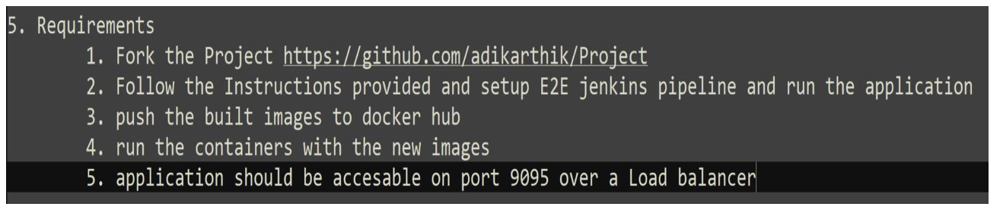

-------------------------------------------------------------------------------------------------------

1. Fork the project

<https://github.com/adikarthik/Project>

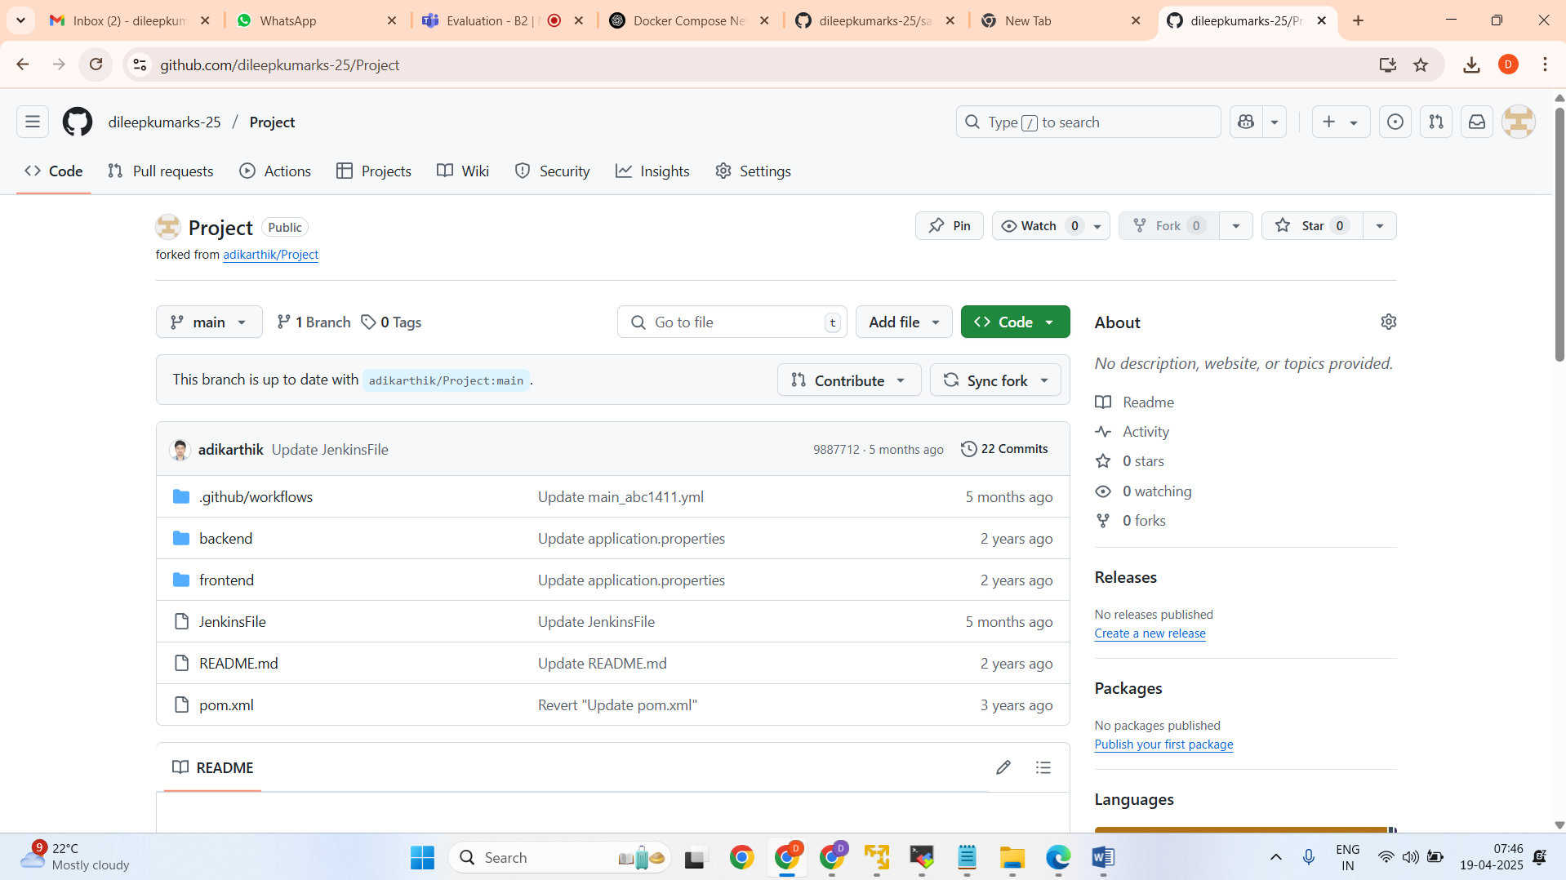

2. E2E Jenkins pipeline

pipeline {

agent any

stages {

stage(‘cloneProject’) {

steps {

git branch:’main’, url:’https://github.com/dileepkumarks-25/Amazon-Jenkins'

}

}

stage(‘clean’) {

steps {

sh ‘mvn clean’

}

}

stage(‘compile’) {

steps {

sh ‘mvn compile’

}

}

stage(‘test’) {

steps {

sh ‘mvn test’

}

}

stage(‘build’) {

steps {

sh ‘mvn clean install’

}

}

}

}

3. push the built images to docker hub

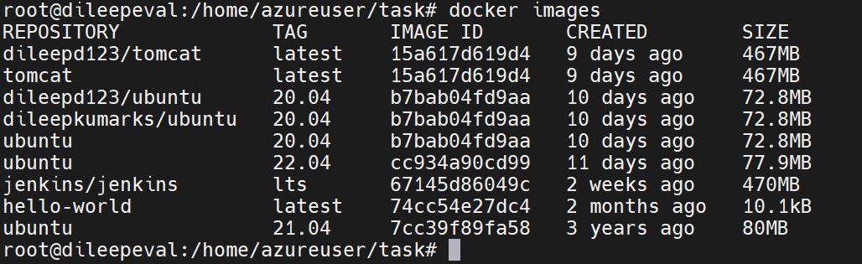

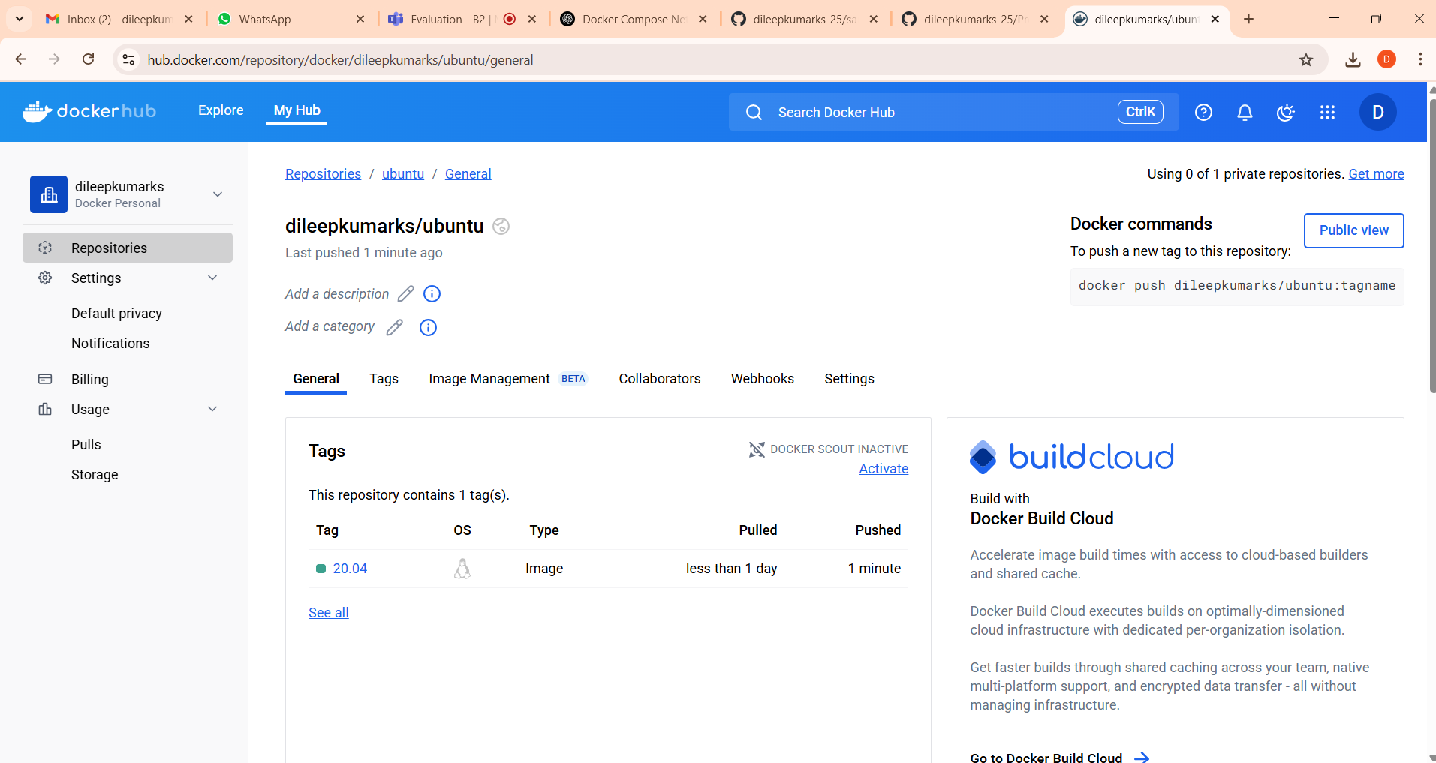

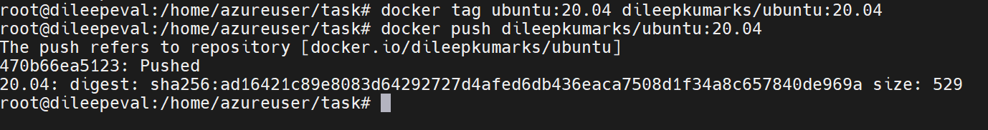

4. Run the container with new images

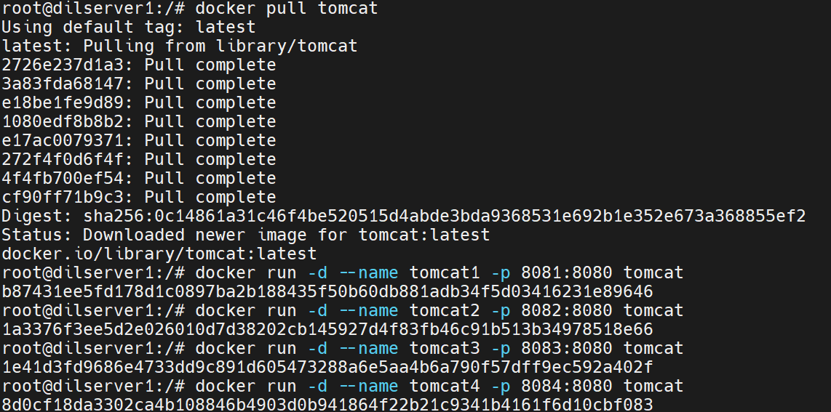



5. application should be accessible on port 9095 over the load balancer

Run the Tomcat Container on Port 9095

docker run -d --name tomcat5 -p 9095:8080 tomcat

Set Up the Load Balancer (Nginx):

sudo nano /etc/nginx/sites-available/default

code: Nginx Configuration

http {

upstream tomcat_servers {

server 127.0.0.1:9095; # Port 9095, where your container is exposed

# Add more servers if you have multiple containers to load balance

}

server {

listen 9095; # Listening on port 9095

location / {

proxy_pass http://tomcat_servers; # Forward traffic to the Tomcat container

proxy_set_header Host $host;

proxy_set_header X-Real-IP $remote_addr;

proxy_set_header X-Forwarded-For $proxy_add_x_forwarded_for;

proxy_set_header X-Forwarded-Proto $scheme;

}

}

}

Restart Nginx:

sudo systemctl restart nginx

<http://localhost:9095>

github link:

https://github.com/dileepkumarks-25/ABC1611